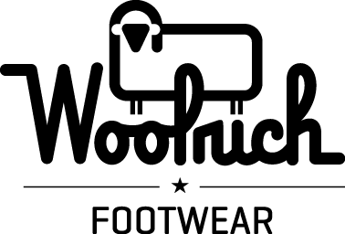

Contact: John McIsaac
john@mcisaacpr.com
503-481-9621 (West Coast)

FOR IMMEDIATE RELEASE

WOOLRICH FOOTWEAR EMPHASIZES FUNCTION AND PERFORMANCE IN FALL 2017 LINES

Men’s and Women’s Weather and Outdoor Rec Lines Feature Proprietary Fully Wooly™ and Wool-Vent Technology

Salt Lake City, UT – January 10, 2017 – At the opening of Outdoor Retailer Winter 2017 today, Woolrich® footwear announced a new emphasis on function and performance for the brand’s fall 2017 men’s and women’s footwear collections.

“Woolrich was founded to provide solid outdoor gear for men and women,” said Sean Beers, President of Woolrich footwear licensee Portland Product Werks. “We’re furthering this effort in footwear by focusing our design engineering on real-world function and problem-solving.”

Highlights of the company’s fall 2017 offering are boots from the men’s and women’s Weather and Outdoor Rec Collections. Men’s standouts include Fully Wooly™ Lace, Fully Wooly Slip, Fully Wooly Green Bay, and Fully Wooly Buckwa, $120-$160 retail. The women’s line is led by three SKUs: one in Outdoor Rec – Rockies II, $150 retail; and two in Weather: Fully Wooly Icecat and Tundracat, $120-$130 retail.

Introduced initially through a few styles in last year’s winter line, Fully Wooly is now incorporated into the entire men’s and women’s Weather Collections, which feature:

- Seam-sealed waterproof construction
- Temperature-rated to -25F/-32C
- Wool and suede upper
- Fleece lining with 360-degree wool-wrap Fully Wooly bootie
- Fully Wooly Frost Barrier foot bed
- Felt flex midsole, which operates as a cold weather barrier
- Injection-molded rubber shell boot construction
- Rubber multidirectional, non-loading winter traction outsole

Additionally, all Woolrich fall 2017 footwear incorporates the brand’s proprietary Wool-Vent™ lining technology, which creates a lining package that is completely different from anything else in the market. The technology utilizes wool’s natural structure to create a breathable, highly perforated, yet waterproof lining that readily absorbs and releases water vapor, keeping the wearer dry and comfortable, no matter the conditions.

About Woolrich
Woolrich has been synonymous with quality outdoor clothing for more than 186 years. The company began in 1830 when John Rich built his first woolen mill in Plum Run, Pennsylvania. What has not changed in all those years is Woolrich's commitment to quality, value, and products that fit the outdoor lifestyle. Learn more at http://www.woolrich.com.

About Portland Product Werks
Portland Product Werks is a premium footwear-licensing group founded in 2012 by Sean Beers and a team of outdoor industry veterans with many years of experience in the footwear industry working with brands such as NIKE, Columbia Sportswear, Sorel and Korkers. The team of industry leaders possesses extensive expertise in brand leadership, premium footwear manufacturing, brand and retail marketing, sales, and logistics. For more information, visit www.portlandproductwerks.com.

###

